**CHAPTER 1**

**INTRODUCTION**

In countries like India, the most widely used and common mode of transport for the peoples is railway transport. As per the current scenario of train accidents we often observe in news that Railway accidents are quite common. It is also one of those modes of transport that faces a lot of challenges due to human errors such as level cross accidents, collisions due to broken track etc. A level cross, an intersection of a road and a railway line, requires human coordination, the lack of which leads to accidents, also the main problem about railway analysis is detection of the crack in the location. If these problems are not controlled at early stages they might lead to a number of derailments resulting in heavy loss of life and property. In traditional system level crossings are managed by the gatekeeper and the gatekeeper is instructed by the means of telephone at most of the level cross from the control room. But the rate of manual error that could occur at these level crosses are high because they are unsafe to perform without actual knowledge about the train time table. Delay in the opening and closing of the gate could lead to railway accidents. In order to avoid the human errors that could occur during the operation of gates and derailment due to crack, the proposed system introduces the concept of railway gate automation and crack detection system.

**1.1 Crack Detection Unit**

An automatic railway track crack detector system which has been proposed here which aims in building a robot that can detect and analyze any kind of crack on the railway line and send the coordinates of that faulty line to the concerned authority. This robot includes two ultrasonic sensors, Accelerometer, GPS, GSM modules, and Arduino Mega based crack detection assembly which is cost effective and robust to facilitate better safety standards in railways. As soon as the robot passed through a crack that might cause the derailment of a train, the ultrasonic sensors or accelerometer sense that and generate a signal. Then this signal is fed into the Arduino Mega. At that point, with the assistance of GSM and GPS modules, an alert SMS consist of the geographic coordinate of that damaged track is sent to the nearby railway authority who can easily take necessary steps to resolve the problem before any major accident occurs.

When any human or animal is on the track the ultrasonic sensor will detect the presence and stop the checking process till they move on. After they have moved on the track, it will continue the process. The aim of our research is to automate the process of detecting cracks on a railway track using cellphone operated vehicle to reduce the human effort.

**1.2 Unmanned Railway Gate Control Unit**

By employing the automatic railway gate control at the level crossing  
the arrival of train is detected by the sensor placed on either side of the gate at about  
5km from the level crossing. Once the arrival is sensed, the sensed signal is sent to  
the microcontroller and it checks for possible presence of vehicle between the gates,  
again using sensors. Subsequently, buzzer indication and light signals on either side  
are provided to the road users indicating the closure of gates. Once, no vehicle is  
sensed in between the gate the motor is activated and the gates are closed. But, for the  
worst case if any obstacle is sensed it is indicated to the train driver by signals (RED)  
placed at about 2km, so as to bring it to halt well before the level crossing.  
When no obstacle is sensed green light is indicated, and the train is to free to move.

The departure of the train is detected by sensors placed at about 1km from the gate. The signal about the departure is sent to the microcontroller, which in turn operates the motor and opens the gate. Thus, the time for which the gate is closed is less compared to the manually operated gates since the gate is closed depending upon the telephone call from the previous station. Also, reliability is high as it is not subjected to manual errors. Using simple electronic components, we have tried to automate the control of railway gates.

**1.3 Track Monitoring System**

The proposed system reduces the human intervention, which collects and transmit data. The desired purpose of the proposed system is to monitor railway infrastructure for accident reduction and its safety. Therefore, periodic monitoring of the infrastructure is to ensure the safety of railways. The existing track surveying systems have some limitations. It takes more time and it is less accurate. We use PIR sensor to detect the presence of human or animal in any tunnel or bridge and indicate them through light signals to train.

**CHAPTER 2**

**LITERATURE SURVEY**

**2.1 PAPER 1**

Nagib Mahfuz, Omor Ahmed Dhali, Safayet Ahmed, Mehen Nigar

“Autonomous Railway Crack Detector Robot for Bangladesh: SCANOBOT” Department of Electrical and Electronic Engineering American International University – Bangladesh (AIUB) 2017 IEEE Region 10 Humanitarian Technology Conference (R10-HTC)21 - 23 Dec 2017, Dhaka, Bangladesh

An automatic railway track crack detector system for Bangladesh Railway has been proposed here which aims in building a robot that can detect and analyze any kind of crack on the railway line and send the coordinates of that faulty line to the concerned authority. This robot includes two ultrasonic sensors, GPS, GSM modules, and Arduino Mega based crack detection assembly which is cost effective and robust to facilitate better safety standards in railways. As soon as the robot passed through a crack that might cause the derailment of a , the ultrasonic sensors sense that and generate a signal. Then this signal is fed into the Arduino Mega. At that point, with the assistance of GSM and GPS modules, an alert SMS consist of the geographic coordinate of that damaged track is sent to the nearby railway authority who can easily take necessary steps to resolve the problem before any major accident occurs. This will save several trains in Bangladesh from an unwanted discontinuity from the rail track.

**2.2 PAPER 2**

Manisha Vohra, S.K. Gabhane

“Efficient Monitoring System for Railways for Crack Detection”

Electronics and Telecommunication Engineering, Rajiv Gandhi Institute of Technology, Mumbai, India 978-1-5386-1442-6/18/©2018 IEEE

Railways serve people with numerous benefits like helping in reaching places very quickly, providing low priced fare travelling, etc. On the basis of such various advantages the railways provide, it is one of the most largely used mode of public transportation. During the recent times in Indian railways, frequent number of accidents have taken place due to fault like presence of cracks on rail tracks. This is making railways a dangerous option for travelling. The monitoring system used at present in Indian railways is proving to be inappropriate. To overcome the shortcomings of the currently used rail monitoring system for detection of cracks an efficient monitoring system has been proposed and explained in this paper. Along with it, the implementation result of the proposed system has been shown and described in the paper**.**

**2.3 PAPER 3**

E Amarnatha Reddy, Ilaiah Kavati, K Srinivas Rao, G Kiran Kumar “A Secure Railway Crossing System Using IoT” Department of CSE, MLR Institute of Technology, Hyderabad - 43, India 978-1-5090-5686-6/17/ ©2017 IEEE

The aim of this paper is to develop a prototype that control the railway gate using the micro-controller. Whenever train touches base at the sensor, caution is activated at the railway crossing so that the general population get instruction that entryway will be shut. At that point the control module initiates and shuts the gates on either side of the track. Once the train crosses, this module naturally lifts the gate. For mechanical operation of a gate DC adapted engines are utilized. We are utilizing an installed controller worked around the 8051 family (AT89C52) for the control. As per the instructions produced at the microcontroller, the proper action (i.e., shut or lift) will be made. This logic was implemented in Embedded C and dumped to the Raspberry PI. This prototype was tested and successfully shuts the gate at the time of train arrival and lifts after train crosses other end.

**2.4 PAPER 4**

Parvathy A, Saji Justus, Mebin George Mathew, Ajan.A  
“Automatic Rail Fault Track Detection for Indian” Railways Electronics and Instrumentation College of engineering Kidangoor Kottayam , India 978-1-5090-5013-0/17/ ©2017 IEEE

Indian railway is the largest railway network in Asia and additionally world’s second largest network operated underneath a single management. The railways became the prime suggests that of transportation because of their capability, speed and responsibleness. Even a small improvement in this sector will aid the overall development of a nation. Due to the gigantic size, it's a tedious task to monitor and maintain the rails in a timely manner. The poor maintenance of the railway tracks will result in accidents. Occurrence of cracks in tracks became a serious concern for the railway. The rail cracks should be identified and corrected as early as possible as it poses a serious threat to the safe operation of the carriages. This proposal aims at elimination of the long prevailing issues in this sector. This effective methodology of continuous observation and assessment of rail tracks might facilitate to stop accidents. This methodology endlessly monitors the rail stress, evaluate the results and provide the rail break alerts such as potential buckling conditions, bending of rails and wheel impact load detection to the concerned authorities.

**2.5 PAPER 5**

Ms. Vaishali B. Niranjane, Ms. Priyanka V. Mandavgade

“RAILWAY TRACK FAULT FINDING ROBOT”  
Dept. of Electronics & Telecommunication Yashwantrao Chavan College of Engineering Nagpur, India IEEE Conference Record # 42487; IEEE Xplore ISBN:978-1-5386-0965-1

The railway tracks are backbone of railway transportation. The cracks in the tracks and slipper misplace creates biggest problem in railway transportation. These cracks are not easily detectable by human eye and it takes more time to resolve. To avoid this problem, we use crack finding and slipper misplace detecting robot, which identify the cracks and slipper misplace tracks and gives indication to remote station. A ROBOT is device designed to carry out one or more tasks without human intervention with speed accuracy. An independent ROBOT acts as on your own structure completes with its controller. The most developed ROBOT is manufactured in artificial intelligence schemes that can be trained from its surrounding and knowledge build its ability based on that facts.

**CHAPTER 3**

**PROBLEM STATEMENT**

Today often we see newspapers very often about the railway accidents happening at un- attended railway gates. Though rail transport in India is growing at a rapid pace, the associated safety infrastructure facilities have not kept up with the mentioned proliferation. The principal problem is the lack of efficient and cost-effective technology to detect problems in the rail tracks and the lack of proper maintenance. It has been seen that approximately 43% of the rail accident cause due to the derailment, and 50% of this accident is cause due to the flaw on the railway track. Those minor cracks are unnoticed by the track-man of railway department who walks 16 km/day along with the railway track for the inspection of the track. This method of inspection is quite unreliable.

There are many accident-prone areas such as tunnels, bridges that need to be monitored. Level crossing and railway gate control need to be taken care as it is also major part of accidents because of human error, bad communication, delay...etc. These all problems lead to provide a bad service to railways in terms of speed, security, accuracy etc...

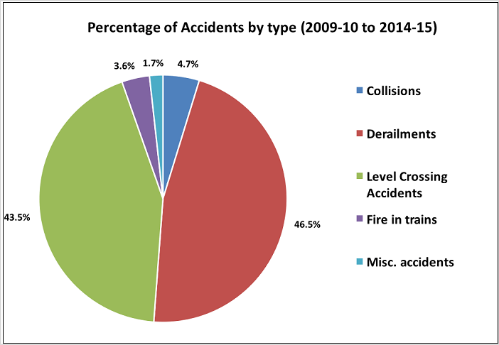

Fig 3(a) Percentage of Railway Accident

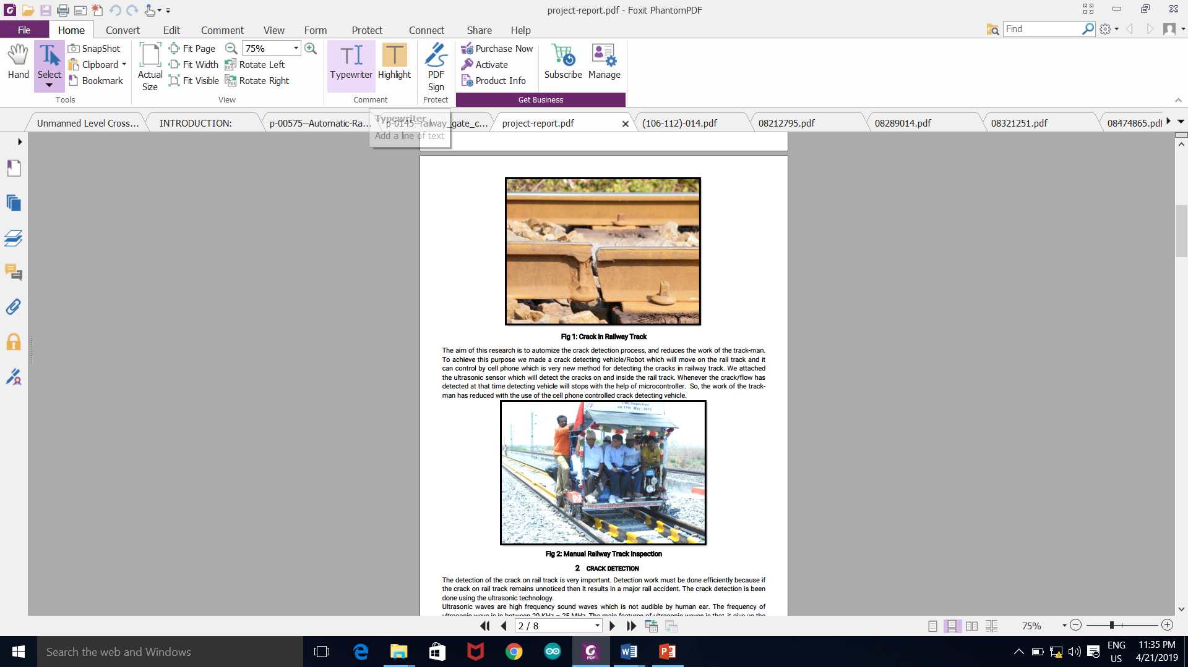

Fig 3(b) Manual Railway Track Inspection



Fig 3(c) Crack in Railway Track

**CHAPTER 4**

**OBJECTIVE**

* This project work is aimed towards addressing the issue by developing an automatic railway track crack detection system integrating an ultrasonic crack sensing module with accelerometer and a communication module based on GSM technology by which information about the location of the crack can be conveyed to a central location enabling the immediate attention and intervention of maintenance personals. The proposed robust and cost-effective system helps to detect these cracks and obstacles on railway tracks. In this paper, an autonomous system is designed for railway track security by developing a microcontroller-based robot.
* To design the unmanned automatic railway gate using embedded platform. In this project, we present intelligent level crossing system to complement the disadvantages of existing system and make persons (train or vehicle drivers, pedestrians, and etc.) more secure. The intelligent level crossing system has been designed and developed, based on case study of existing accidents at level crossing.
* We are also going to implement the track monitoring system project in hilly region, remote region, bridges or in the tunnels. By doing so we are going to make sure that no animal gets hit by trains. The desired purpose of the proposed system is to monitor railway infrastructure for accident reduction and its safety.

**CHAPTER 5**

**METHODOLOGY**

**5.1 BLOCK DIAGRAM**

**5.1.1CRACK DETECTION UNIT**

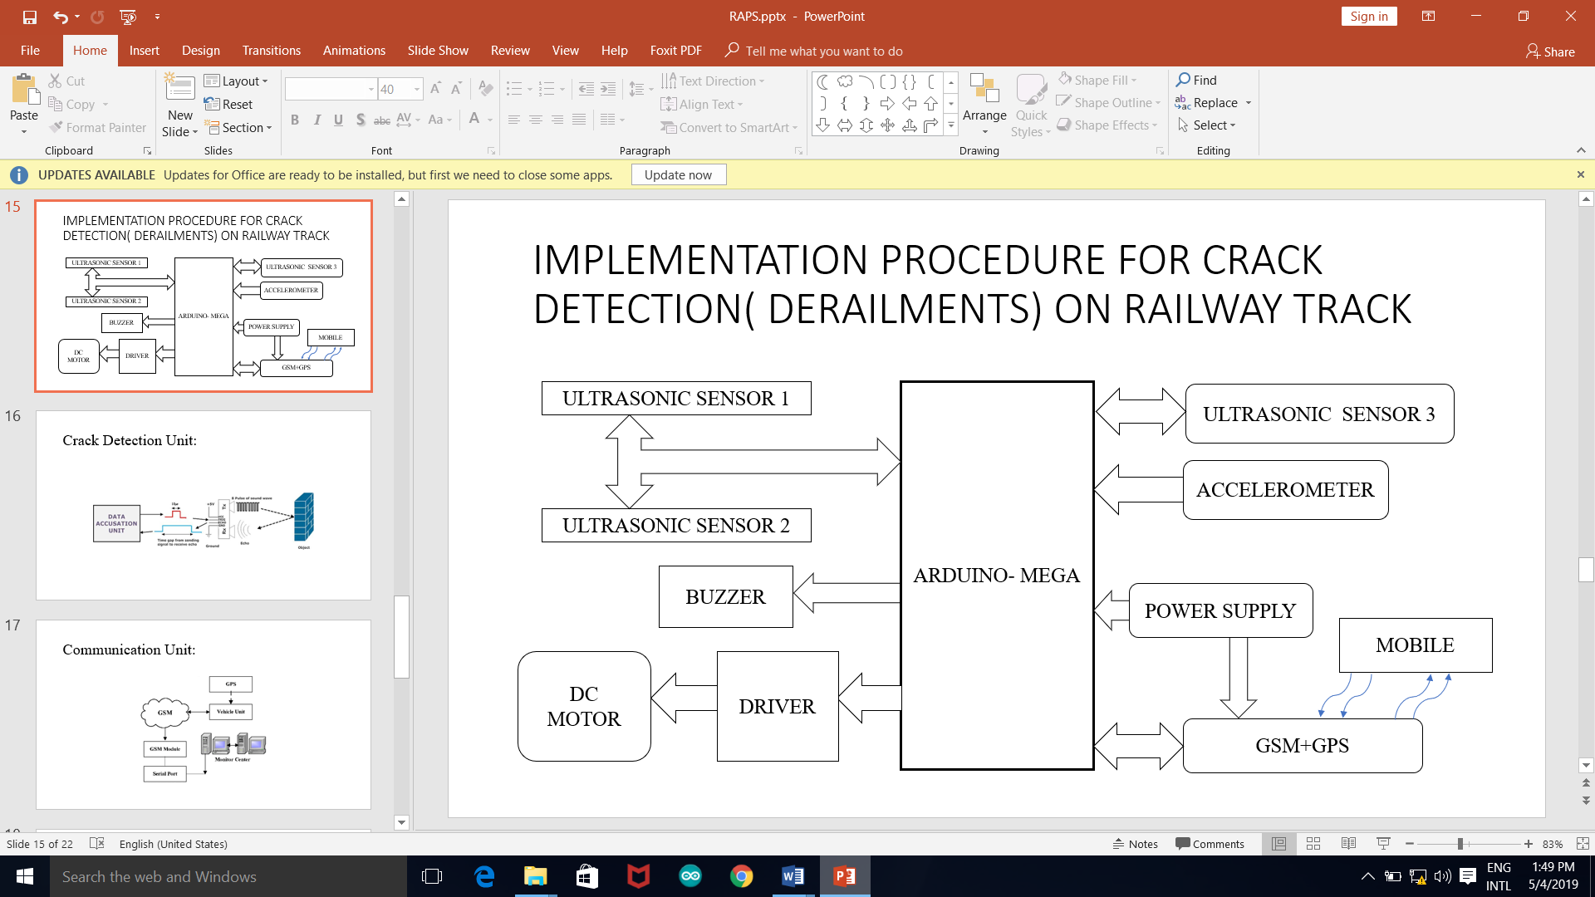

Fig 5.1.1 Block Diagram of Crack Detection Unit

The proposed crack detector robot is a microcontroller based low-cost intelligent device. The cracks in the railway track can be sensed by using ultrasonic sound wave. This sensor is connected to Arduino Mega which is the central control unit of this project. DC geared motor is used to move the wheels on the track. A motor driver circuit that passes commands to the dc gear motor and four wheels run the robot. The chassis of this prototype robot made with the acrylic material. This device also has a feature of sending the location information using GPS and about the fault via SMS alert using a GSM module.

1.Ultrasonic Sensor

The ultrasonic sensor is also known as transducer use sound waves rather than light, making them ideal for stable detection of the uneven surface. The working principle is similar compared to radar/sonar which evaluates attributes of target by interpreting the echoes from radio or sound waves respectively. These sensors work well for the application that requires precise measurement. Sensors calculate the time interval between sending the signal and receiving the echo to determine the evaluation of the surface to an object. In this project, the object is a railway track. The ultrasonic sensors are used because these sensors result more accurate than any other sensors that are available in the market. On the other hand, it also reduces the cost.

2. Arduino Mega

After getting the signal from the ultrasonic sensor is fed into the Arduino Mega. A GPS, GSM modem, and an motor driver etc. are connected with Arduino also.

3. Buzzer

It generates sound to indicate obstacle after getting a signal from Arduino Mega.

4. Motor and driver circuit

DC geared motor is used to run the robot. An optical encoder is included with Arduino Mega to measure the RPM so that the authority can know the exact location of the robot and there is a command given in Arduino Mega to skip the regular frame gap of the railway track which is default feature created its implementation period. A motor driver circuit is made to run the motor by using motor driver IC L293D. It basically works on the concept of H-bridge.

5. Global Positioning System

A Global Positioning System (GPS) device is used to find out the longitude and latitude data. When a crack is noticed by sensor the Arduino Mega collect the location data from this sensing Device.

6. GSM modem

A GSM module is specialized type of modem which enables a Subscriber Identity Module (SIM) card and operates over a subscription to a mobile operator seems like a mobile phone. The module exposes an architecture that allows applications to send and receive messages over the modem interface. The Arduino Mega sends the crack detection notification with location data to the authority through this GSM modem. In the circuit, GSM modem is representing through the Virtual Terminal.

7.Accelerometer

Accelerometers are devices that measure acceleration, that is the rate of change of velocity. However, this will vary slightly with elevation. Accelerometers area unit helpful for sensing vibrations in systems or for orientation applications.

8.Power Supply

A 9v battery is used to power up Arduino Mega. A 12v 2A power supply is given to Gsm/Gps module.

**5.2** **Unmanned Railway Gate Control Unit**

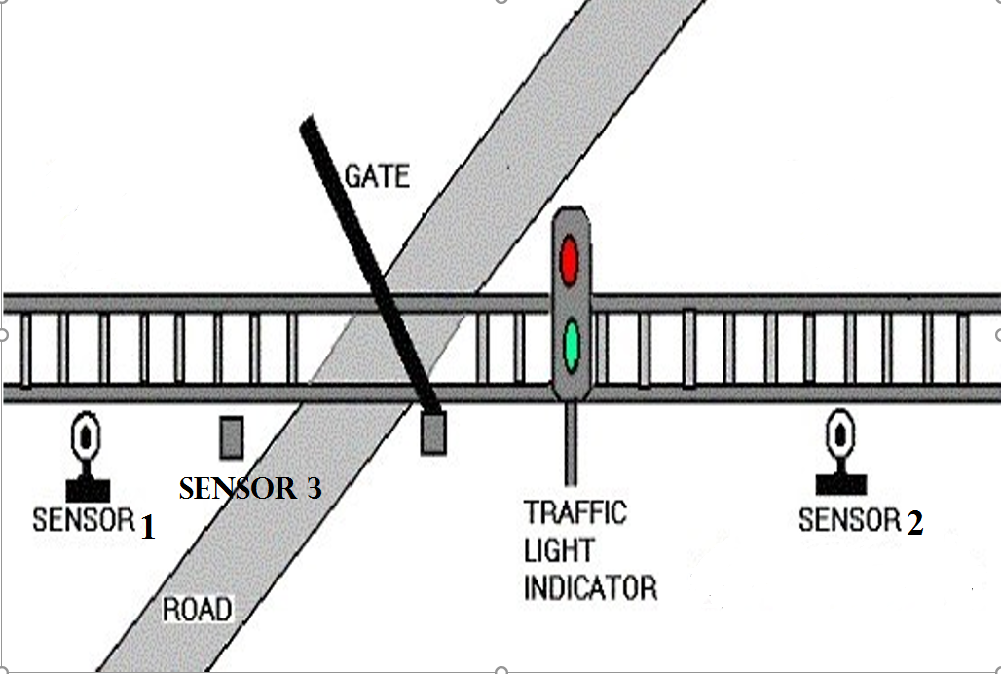

Fig 5.1.2(a) Unmanned Railway Gate Model

In the proposed framework, different sensors are used to detect the train arrival and departure. This framework uses three sensors to control the rail arrival and departure. We programmed different sensors and motors using Arduino. The functional diagram of the proposed framework is shown in Fig. 5.1.2. The following materials and components are used in the proposed automatic railway gate control system.

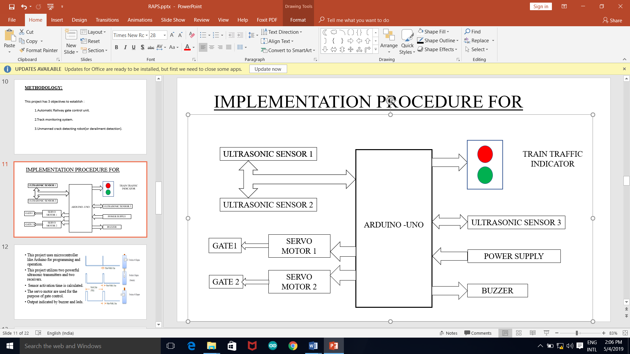

Fig 5.1.2(b) Block Diagram of Unmanned Railway Gate

1.Sensors

The sensor recognizes and responds to events from the physical environment. They are placed at both ends of railway crossing and senses the arrival and departure of the train. The  
sensor detects the presence of train on either side of the gate and sends the signal to Arduino. It is also taken care that it doesn’t detect any other obstacles at certain distance by limiting its sensing distance. Another sensor is used at the railway gate to make sure that gate closes only when there is no motion of vehicles.

2 Arduino board

The Arduino Uno is used to send the information about the train status with the help of sensors. It consists of the Arduino code in c programming. The system should contain certain software to run and accept the code.

3. Servo motor

The servo motors are used for mechanical control of the gates that rotate forward or reverse direction. The motor is able to rotate to max of 180 degree. The motor will rotate to different angles depending upon angle specified in the program. With the use of servo motor instead of dc motor, we can achieve an accurate positioning and/or speed control.

4. Buzzer, Power supply

Buzzer and light signal are used to inform the user regarding the arrival and departure of train.  
Power Supply is required to provide 9v dc battery to power up Arduino.

5. Arduino Integrated Development Environment

Arduino software is different from windows to windows. The task that should be done  
is given to the Arduino software. The code is in c program. “The Arduino Integrated Development Environment (i.e., Arduino IDE) contains a text editor for writing code, a message area, a text console, a toolbar with buttons for common functions and a series of menus. It connects to the Arduino and hardware to upload programs and communicate with them”. Fig. 2 shows the flowchart of the proposed prototype.

Overall it does the following work:

1.To detect the train arrival and departure

2.To open and close the railway gate automatically by using the servo motor

3.Buzzer and light signal for warning the road users regarding the train arrival

**5.1.3** **Track Monitoring System**

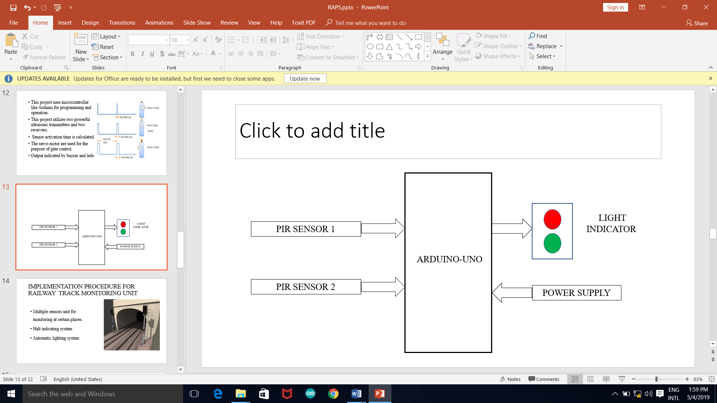

Fig 5.1.3(a) Block Diagram of Tunnel Monitoring

1.Arduino Uno

The Arduino Uno is used to send the information about the train status with the help of sensors. It also sends the warning signals to led to indicate the presence of any living thing.

2. PIR Sensor

A passive infrared sensor is an electronic sensor that measures infrared light radiating from objects in its field of view. They are motion-based detectors. It detects living beings and sends the signal to Arduino.

3.Power Supply

A 9v power supply is used to power up Arduino Uno.

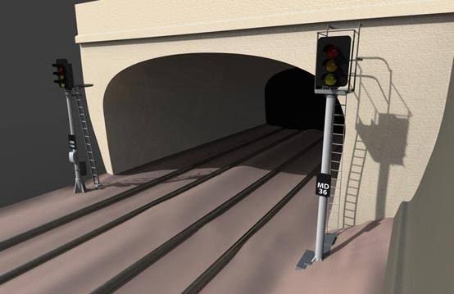

Fig 5.1.3(b) Tunnel Monitoring

* 1. **OPERATION OF COMPONENTS**

**5.2.1 ULTRASONIC SENSOR**

The Arduino Ultrasonic Range Detection Sensor with Arduino calculates distance from objects. The output of an LED alters with PWM according to how close an object is to the sensor. So, nearer the object the brighter the LED . This Sensor works by sending an ultrasound pulse at around 40 KHz. It then gets the echo back and calculates the time taken in µsec. We can trigger a pulse as fast as 20 times a second and it can determine objects up to 3 meters away and as near as 3cm. It needs a 5V power supply to run. Arduino can be added to Ultrasonic Range Detection Sensor using only 4 pins Power, Ground, Trigger and Echo. Since it needs 5V and Arduino provides 5V, we will use this to power it. There are 2 sets of 5 pins, 1 set we can use, the other is for programming the PIC chip. Supply module with 5V, the output will be 5V while obstacle in range, or 0V if not.

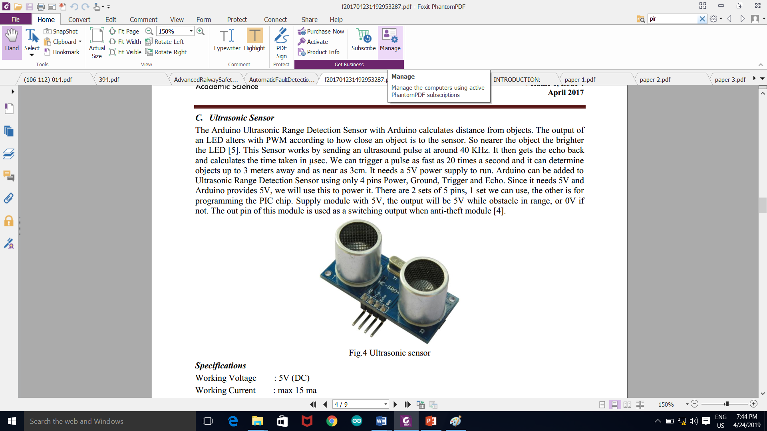

Fig.5.2.1(a) Ultrasonic sensor

**Specifications:**  
Working Voltage : 5V (DC)

Working Current : max 15 ma

Operating frequency: 40HZ

Output Signal : 0-5V (Output high when obstacle in range)

Sentry Angle : max 15 degree

Sentry Distance : 2cm - 500cm

High-accuracy : 0.3cm

Input trigger signal : 10us TTL impulse

Echo signal : output TTL PWL signal

Size : 45*20*15mm

Interface

Pin:1 VCC

Pin:2 Trigger(T)

Pin:3 Echo(R)

Pin:4 GND

Module Working Principle

1.Adopt IO trigger through supplying at least 10µs sequence of high level signal.

2. The module automatically sends eight 40 kHz square wave and automatically detect returning pulse signal,

3. If there are signals returning through outputting high level and the time of high level continuing is the time of that from the ultrasonic transmitting to receiving. Test distance = (high level time * sound velocity (340M/S) / 2.

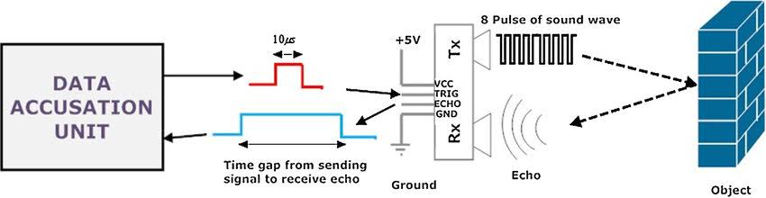

Fig 5.2.1(b) Working of Ultrasonic Sensor

* + 1. **Arduino UNO/MEGA**

The Arduino UNO is a microcontroller board based on the ATmega328.Arduino is open-source electronics prototyping platform and it is intended for designing, creating interactive objects or environments. Arduino boards are relatively inexpensive compared to other microcontroller platforms. A basic Arduino Uno board has been shown in Fig.5.2.2

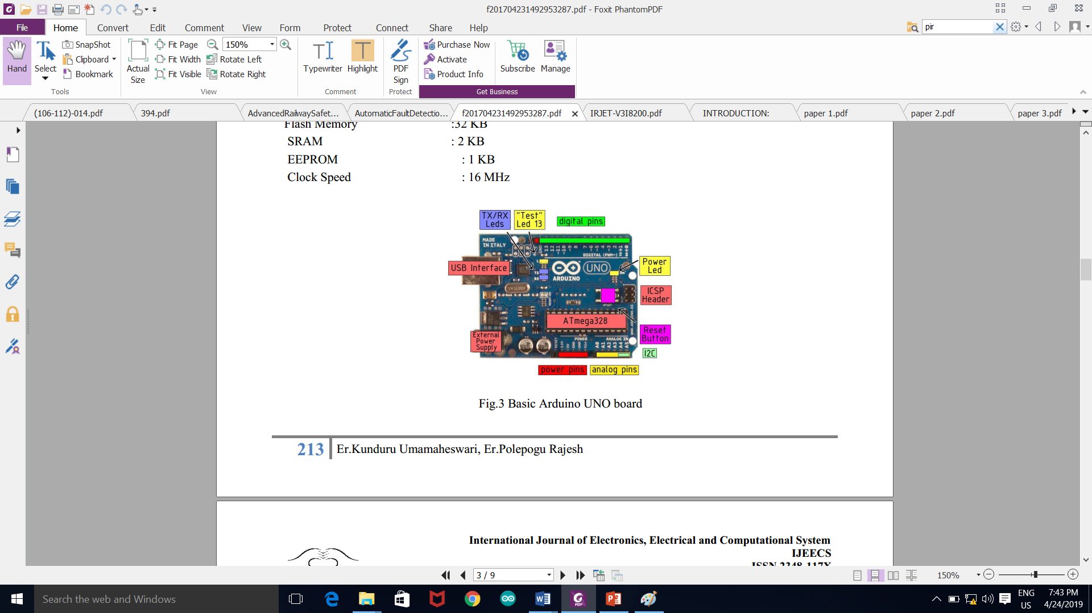

Fig 5.2.2 Basic Arduino-Uno Board

**Features:**1. Cross-platform

The Arduino software runs on Windows, Macintosh OSX, and Linux operating systems.  
2. Simple, clear programming environment

The Arduino programming environment is easy-to-use for beginners and flexible enough for the advanced users.

3. Source and extensible software

The Arduino software is published as open source Open tools, available for extension by experienced programmers. The language can be expanded through C++ libraries.  
4. Open source and extensible hardware.

**Technical Specifications**

|  |  |
| --- | --- |
| Microcontroller | ATmega328 |
| Operating Voltage | 5V |
| Input Voltage (recommended) | 7-12V |
| Digital I/O Pins 14 | PWM o/p |
| Analog Input Pins | 6 |
| DC Current per I/O Pin | 40 mA |
| DC Current for 3.3V Pin | 50 Ma |
| Flash Memory | 32 KB |
| SRAM | 2 KB |
| EEPROM | 1 KB |
| Clock Speed | 16 MHz |

Table 5.2.2 Arduino Specifications

* + 1. **GSM / GPRS + GNSS - SIM808**

SIM808 module is a complete Quad-Band GSM/GPRS module which combines GPS technology for satellite navigation. The compact design which integrated GPRS and GPS in a SMT package will significantly save both time and costs for customers to develop GPS enabled applications. Featuring an industry-standard interface and GPS function, it allows variable assets to be tracked seamlessly at any location and anytime with signal coverage.

**General features:**

Quad-band 850/900/1800/1900MHz

GPRS multi-slot class 12/10

GPRS mobile station class B

Compliant to GSM phase 2/2+

Class 4 (2 W @ 850/900MHz)

Class 1 (1 W @ 1800/1900MHz)

Bluetooth: compliant with 3.0+EDR

Control via AT commands (3GPP TS 27.007, 27.005 and SIMCOM enhanced AT Commands)

Supply voltage range 3.4 ~ 4.4V

Low power consumption

Operation temperature:-40℃ ~85℃

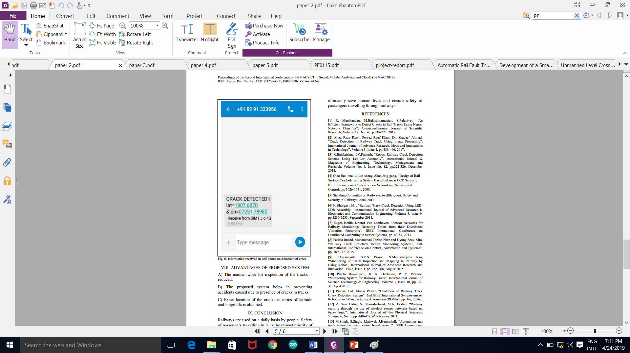

Fig 5.2.3(a) Information Received in Cell Phone on Detection of Crack

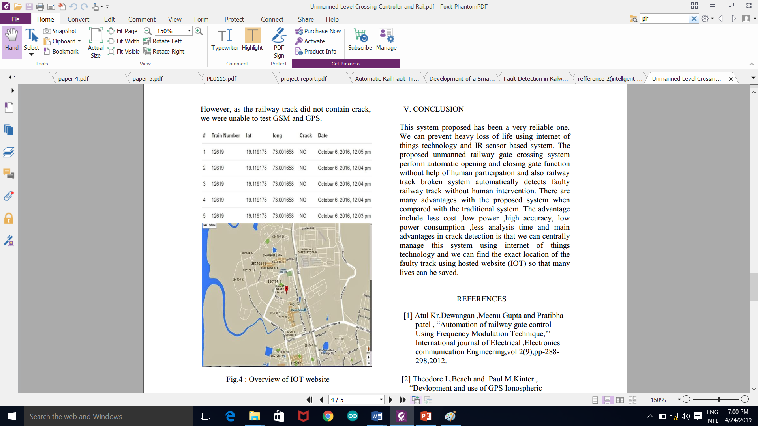

Fig 5.2.3(b) Location of The Crack Shown in Google Map

* + 1. **Motor Driver**

L293D is a typical Motordriver or MotorDriver IC which allows DC motor to drive on either direction. L293D is a 16-pin IC which can control a set of two DC motorssimultaneously in any direction. It means that you can control two DC motor with a single L293D IC. Dual H-bridge MotorDriver integrated circuit (IC). The input to the motordriver IC or motordriver circuit is a low current signal. The function of the circuit is to convert the low current signal to a high current signal. This high current signal is then given to the motor. The motor can be a brushless DC motor, brushed DC motor, stepper motor, other DC motors etc.

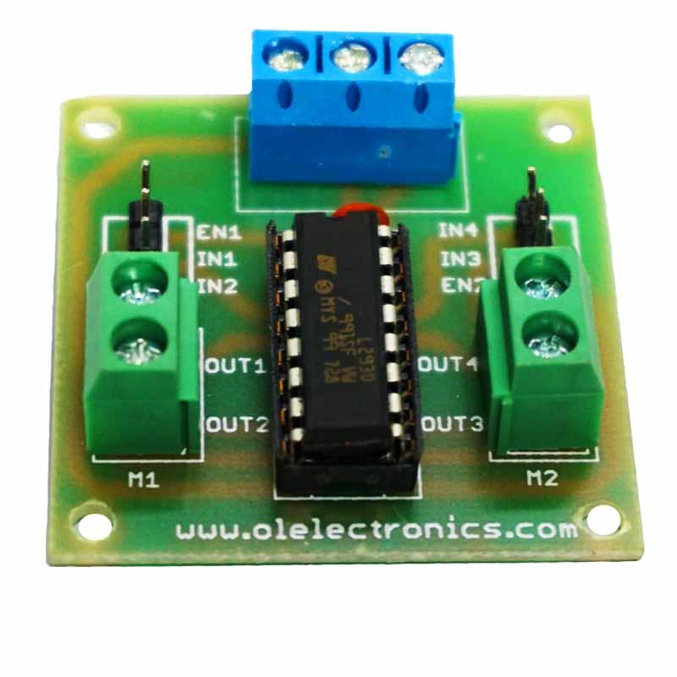

Fig 5.2.4 L293D driver

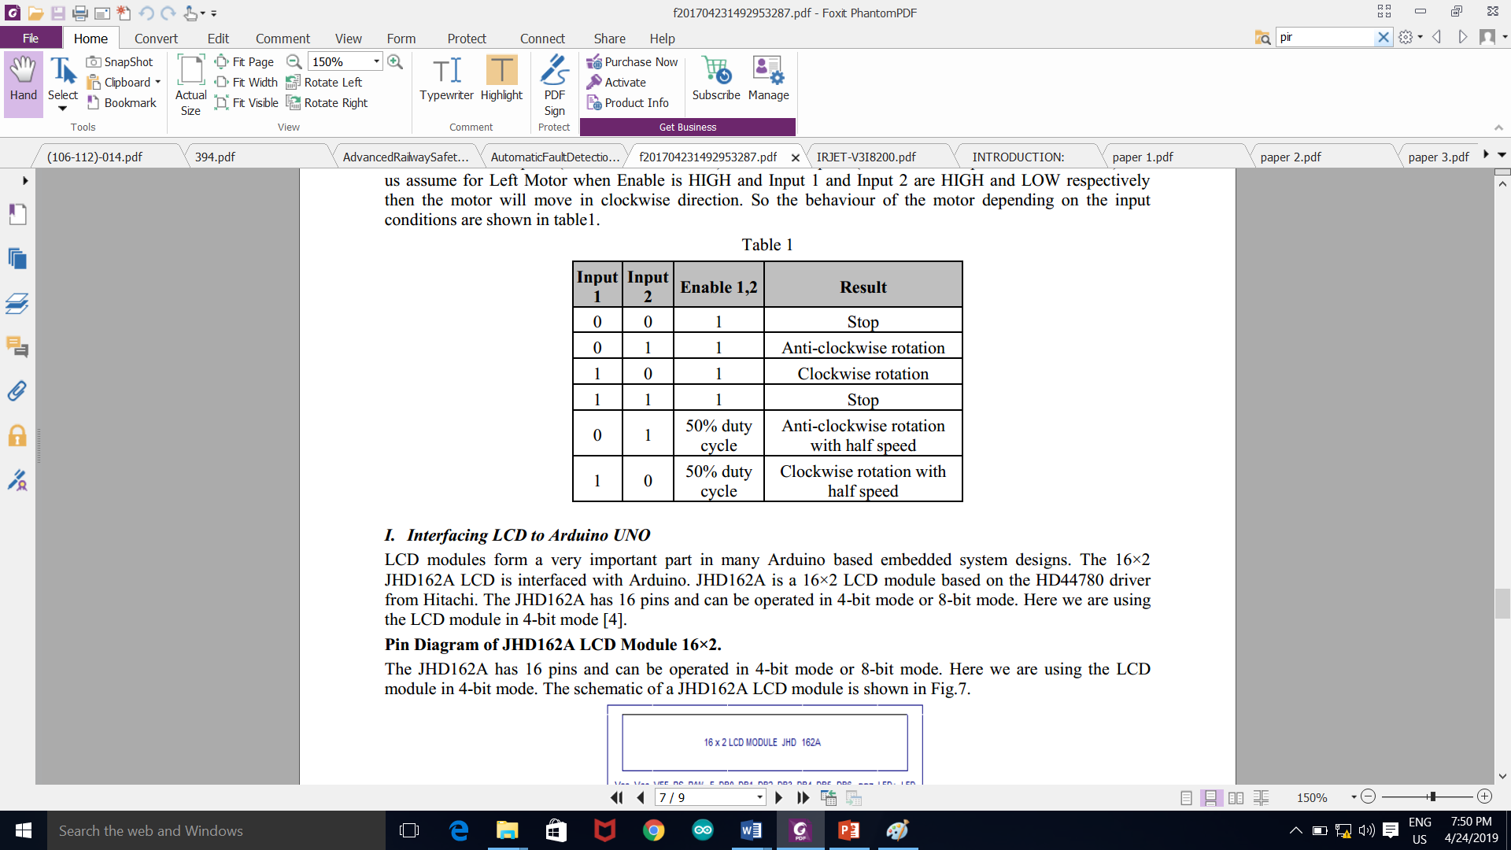

Table 5.2.4 Operation of Motor

* + 1. **PIR SENSOR**

Types of IR sensors. There are basically twotypes of IR sensor: Passive IR sensors and Active IR sensors. Passive Infrared Sensors (PIR sensors) do not need an infrared source to operate. PIR sensors detect the infrared rays emitted.

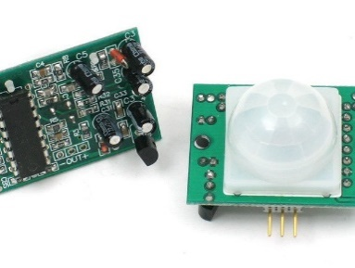

Fig 5.2.5(a) PIR Sensor

An infrared sensor is an electronic device, that emits in order to sense some aspects of the surroundings. An IR sensor can measure the heat of an object as well as detects the motion. These types of sensors measure only infrared radiation, rather than emitting it that is called as a passive IR sensor.The sensor has very good and stable response even in ambient light or in complete darkness. When the sensor is idle, both slots detect the same amount of IR, the ambient amount radiated from the room or walls or outdoors. When a warm body like a human or animal passes by, it first intercepts one half of the PIRsensor, which causes a positive differential change between the two halves.

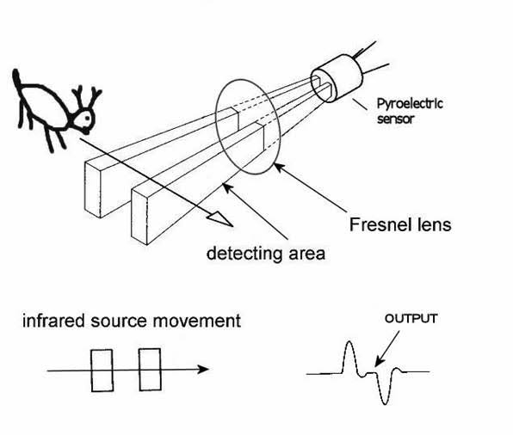

Fig 5.2.5(b) Operation of PIR Sensor

* + 1. **Accelerometer**

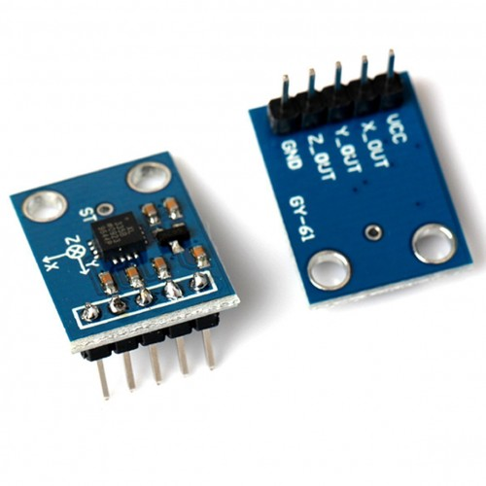

Fig5.2.6(a)Accelerometer

An accelerometer is an electromechanical device used to measure acceleration forces. Such forces may be static, like the continuous force of gravity or, as is the case with many mobile devices, dynamic to sense movement or vibrations. Acceleration is the measurement of the change in velocity, or speed divided by time. There are many different ways to make an accelerometer! Some accelerometersuse the piezoelectric effect - they contain microscopic crystal structures that get stressed by accelerative forces, which causes a voltage to be generated. Another way to do it is by sensing changes in capacitance. Accelerometers have a wide usable frequency range where sensitivity is relatively flat. You can choose from two axial types of accelerometers. The most common accelerometermeasures acceleration along only a single axis. This type is often used to measure mechanical vibration levels. In reality, accelerometers have long been used to measuredisplacement. However, it is important to understand that displacementmeasured with an accelerometer is not the same displacementmeasured with shaft riders or eddy current style vibration transducers.

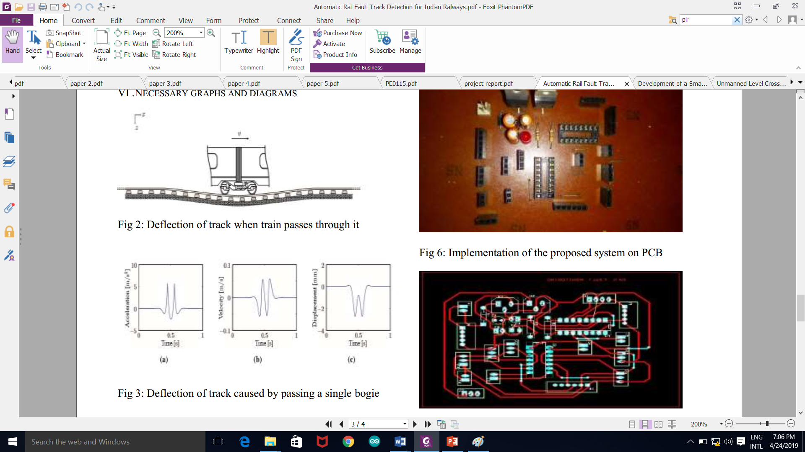

Fig 5.2.6(b) Accelerometer Deflection Due to Derailments

**5.2.7 SERVO MOTOR**

Servo implies an error sensing feedback control which is utilized to correct the performance of a system. Servo motors are DC motors that allows for precise control of angular position. They are actually DC motors whose speed is slowly lowered by the gears. The servo motors usually have a revolution cutoff from 90° to 180°. A few servo motors also have revolution cutoff of 360° or more. Their rotation is limited in between the fixed angles.

A servo motor consists of three wires- a black wire connected to ground, a white/yellow wire connected to control unit and a red wire connected to power supply. The function of the servo motor is to receive a control signal that represents a desired output position of the servo shaft and apply power to its DC motor until its shaft turns to that position.

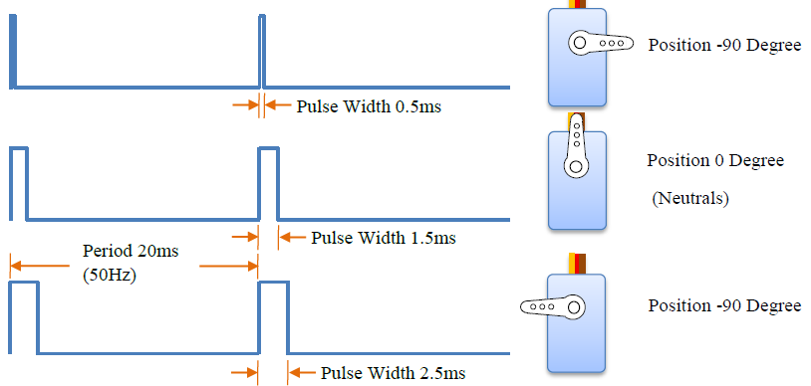

Fig 5.2.7 Operation Of Servo Motor

The Servo Motor basically consists of a DC Motor, a Gear system, a position sensor and a control circuit. The DC motors get powered from a battery and run at high speed and low torque. The Gear and shaft assembly connected to the DC motors lower this speed into sufficient speed and higher torque. The position sensor senses the position of the shaft from its definite position and feeds the information to the control circuit. The control circuit accordingly decodes the signals from the position sensor and compares the actual position of the motors with the desired position and accordingly controls the direction of rotation of the DC motor to get the required position. The Servo Motor generally requires DC supply of 4.8V to 6 V.A servo motor is controlled by controlling its position using Pulse Width Modulation Technique. The width of the pulse applied to the motor is varied and send for a fixed amount of time.

**CHAPTER 6**

**ADVANTAGE OF PROPOSED SYSTEM**

* The manual work for inspection of the tracks is reduced.
* It is cost effective and affordable.
* Less time consuming compared to current manual crack detection system.
* Accurate gate open/close.
* There is no delay.
* Exact location of the cracks in terms of latitude and longitude is obtained.
* This device is portable.
* We can control it manually or automatically by sending SMS.
* Quick response is achieved.
* Simple in construction.
* A fully automated security system ensures a safe railway track to carry out thousands of passengers.
* Easy to maintain and repair.
* No fire hazard problem due to over loading.
* Continuous operation is possible without stopping.
* Independent of time of the day, may it be day or night.
* Two-way traffic indicating system.
* Reduce Human intervention.
* Safety and quality of services.

.

**CHAPTER 7**

**CONCLUSION**

**7.1 PROPOSED MODEL**

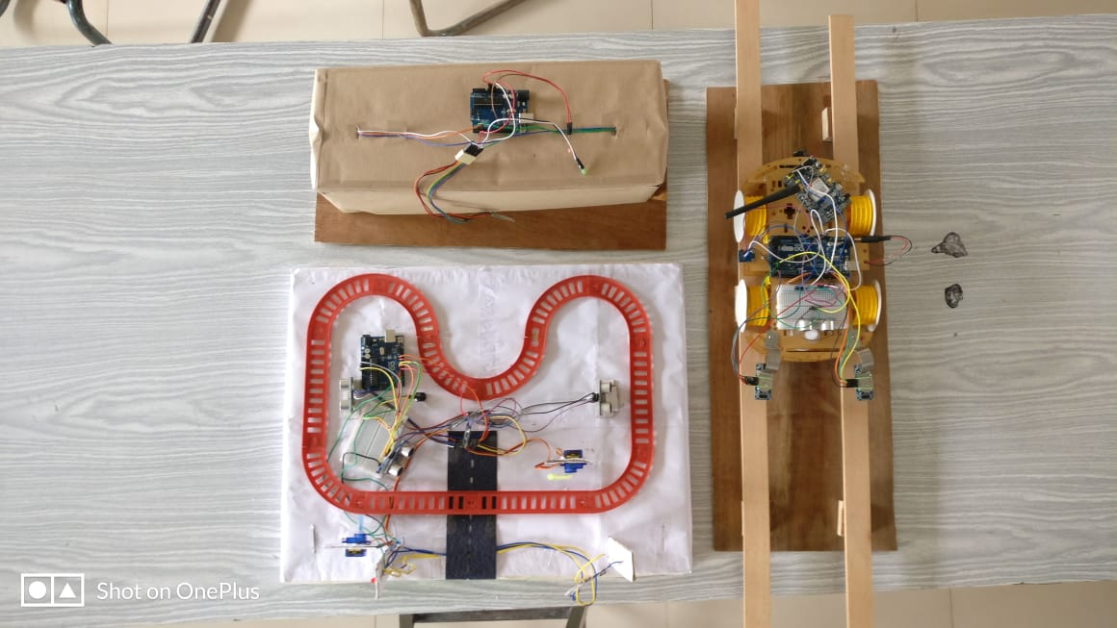

Fig 7.1 Proposed Model

**7.2 RESULTS**

**7.2.1 Crack Detection Unit**

1. Only registered person is able to operate it by sending secured password to start the cart.
2. Buzzer sirens when it encounters any obstacle.
3. The cart stops whenever there is a presence of an obstacle and continues moving on when track becomes free.
4. The cart stops when it detects any crack or derailments and sends message of location to the registered person.

**7.2.2 Unmanned Automatic Railway Gate Control Unit**

1. Buzzer sirens when it detects train on either side of gate and switches off when the gate is closed.
2. Servomotor closes the gate when the train is arriving and there is no movement off the track. The gate opens after the train passes certain distance after the gate.
3. Led:
   1. Initially Red indicating to train that gate is opened and has to reduce its speed.
   2. Once the gate is closed, it turns green signal indicating to train that track is free.
   3. Once the train passes of the gate, the led turns back to red.

**7.2.3 Track Monitoring System**

1. Led :
   1. In the absence of living being it remains green indicating to train that track is free.
   2. If there is any presence of living being then it turns Red.

**CHAPTER 8**

**REFERENCES**

[1] Nagib Mahfuz, Omor Ahmed Dhali, Safayet Ahmed, Mehen Nigar “Autonomous Railway Crack Detector Robot for Bangladesh: SCANOBOT” Department of Electrical and Electronic EngineeringAmerican International University – Bangladesh (AIUB) 2017 IEEE Region 10 Humanitarian Technology Conference (R10-HTC)21 - 23 Dec 2017, Dhaka, Bangladesh

[2] Manisha Vohra, S.K. Gabhane “Efficient Monitoring System for Railways for Crack Detection” Electronics and Telecommunication Engineering, Rajiv Gandhi Institute of Technology, Mumbai, India 978-1-5386-1442-6/18/©2018 IEEE

[3] E Amarnatha Reddy, Ilaiah Kavati, K Srinivas Rao, G Kiran Kumar “A Secure Railway Crossing System Using IoT” Department of CSE, MLR Institute of Technology, Hyderabad - 43, India 978-1-5090-5686-6/17/ ©2017 IEEE

[4] Parvathy A, Saji Justus, Mebin George Mathew, Ajan.A “Automatic Rail Fault Track Detection for Indian” Railways Electronics and Instrumentation College of engineering Kidangoor Kottayam , India 978-1-5090-5013-0/17/ ©2017 IEEE

[5] Ms. Vaishali B. Niranjane, Ms. Priyanka V. Mandavgade “RAILWAY TRACK FAULT FINDING ROBOT” Dept. of Electronics & Telecommunication Yashwantrao Chavan College of Engineering Nagpur, India IEEE Conference Record # 42487; IEEE Xplore ISBN:978-1-5386-0965-1